**Category 5e Unshielded Keystone Jack**

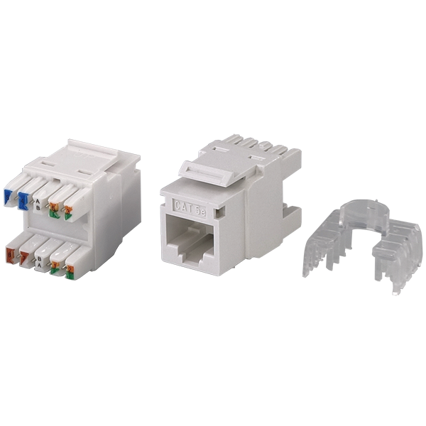

Category 5e keystone jack is designed for superior performance that meets or exceeds industry standard ANSI/TIA-568.2-D and ISO/IEC 11801 2nd edition requirements. The keystone jack will balance signal transmission of insertion loss and crosstalk from 1 to 100 MHz. Jacks are available in 9 colors to match housing or allow color coded designation port in compliance with TIA-606 requirements.

## **Features**

Contacts are phosphor bronze plated with 50 micro inches hard gold

Option for KRONE/110 Universal IDC connector or tool-free type

Supplied with plastic strain relief cap for IDC connectors

Large selection of colors, provides many options of color coded designation port

Polycarbonate 94V0 rated

Itertek ETL / Force EC Cat.6A VERIFIED

4PPoE compliant in accordance with IEEE802.bt Type 4

**Ordering Information**

|  |  |
| --- | --- |
| **Part No.** | **Description** |
| **0A58RP0e0-XX** | RJ45, 8-Conductor Cat.5e, KRONE/110 IDC, Unshielded, 180 degree, H.D. version, fits 0.5U panel |
| **1A58TP0e0-XX** | RJ45, 8-Conductor Cat.5e, Tool-free, Unshielded, 180 degree, H.D. version |
| **1K58KP0e0-XX** | RJ45, 8-Conductor Cat.5e, KRONE/110 IDC, Unshielded, 90 degree, H.D. version |
| **2K58TP0e0-XX** | RJ45, 8-Conductor Cat.5e, KRONE/110 IDC, Unshielded, 90 degree, Short depth design, L=28.8mm |
| **0T58TP0e0-XX** | RJ45, 8-Conductor Cat.5e, Tool-free, Unshielded, 90 degree, H.D. version |

***“XX” = Color choices – Ivory (IV), White (WH), Grey (GY), black (BK), Red (RD), Orange (OR), Blue (BL), Green (GN), Yellow (YL)***